Corner Grocer Notes

When first creating this program, the first thing that I wanted to implement was a Print Menu function. 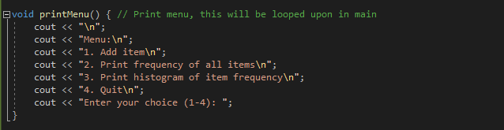Doing this makes menu navigation easier to program later down in the main because I can just create a quick loop to display the menu. 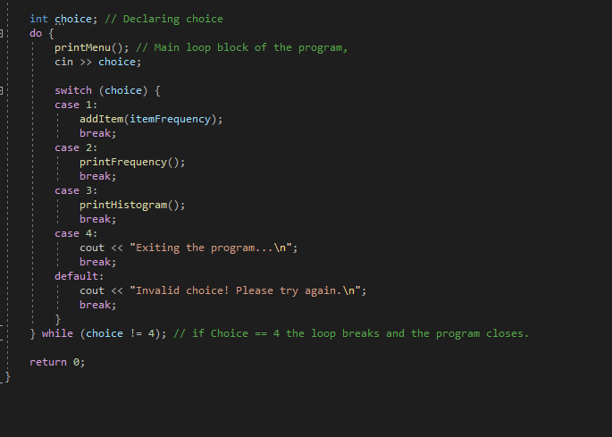

A choice that I decided to make was have the program get all of its data from a backup file and adding an item adds this to the backup.dat

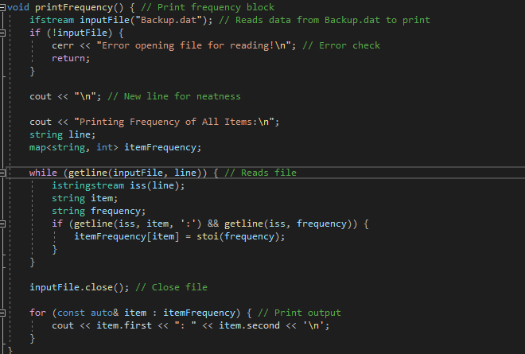

I decided to go for this approach because it didn’t make a lot of sense to me to keep backup data without the ability to read it, and perhaps our client would like to keep data throughout multiple days of work, without writing over it. At the start of the main, I created a block that checks and creates the backup.dat if it doesn't exist.

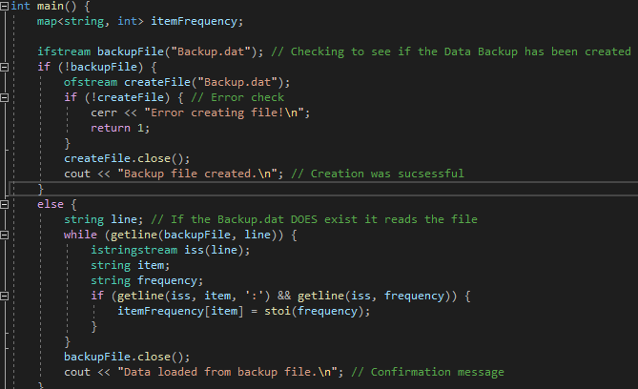

This also displays a message when the program is first run 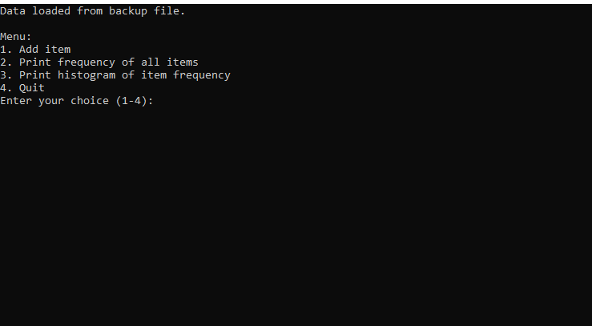

And looks like this if the file didn’t exist.

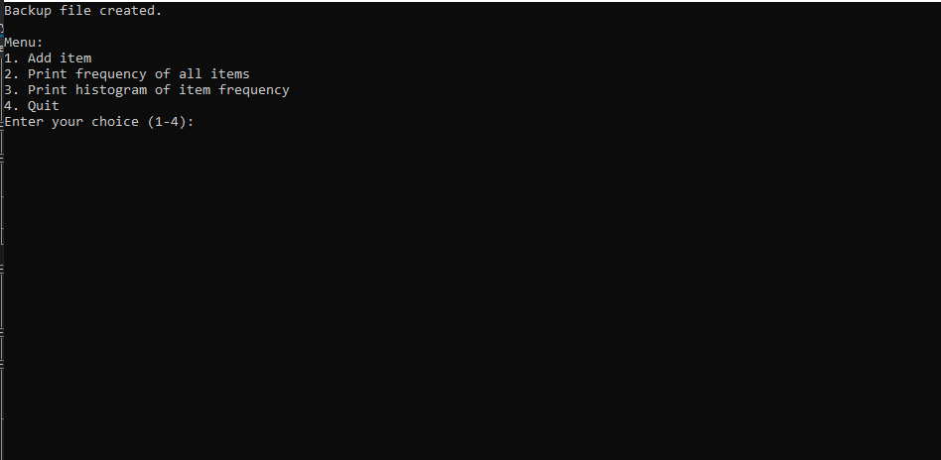

The way that I implemented my writing to a file was a simple Write to output with a new line afterward this also writes to Backup.dat as well

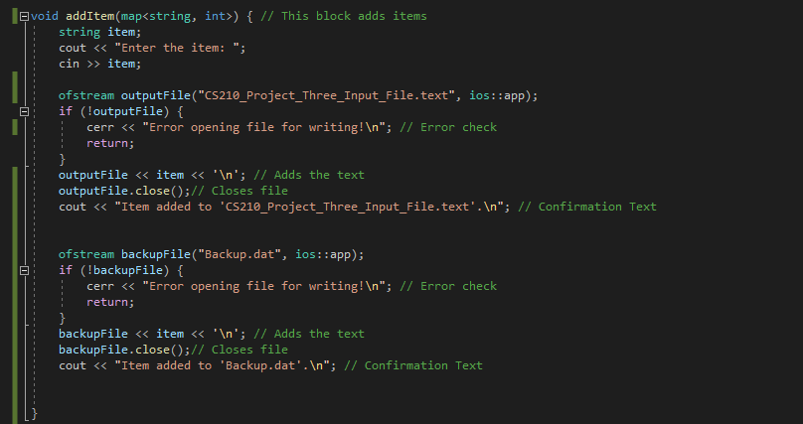

The way that I handled my Print Frequency and Print Histogram was very similar to one another

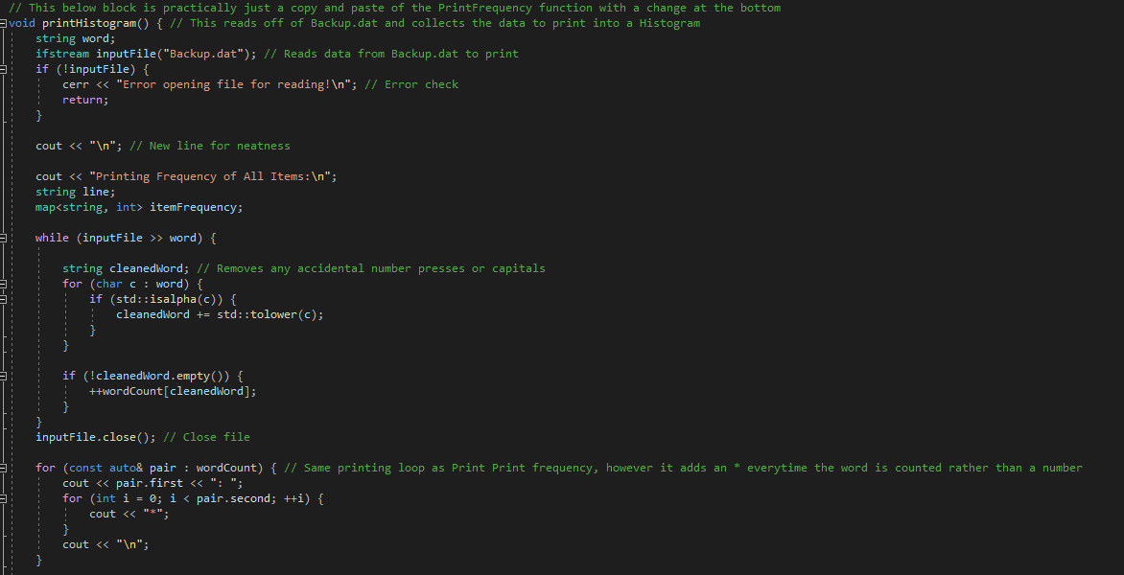

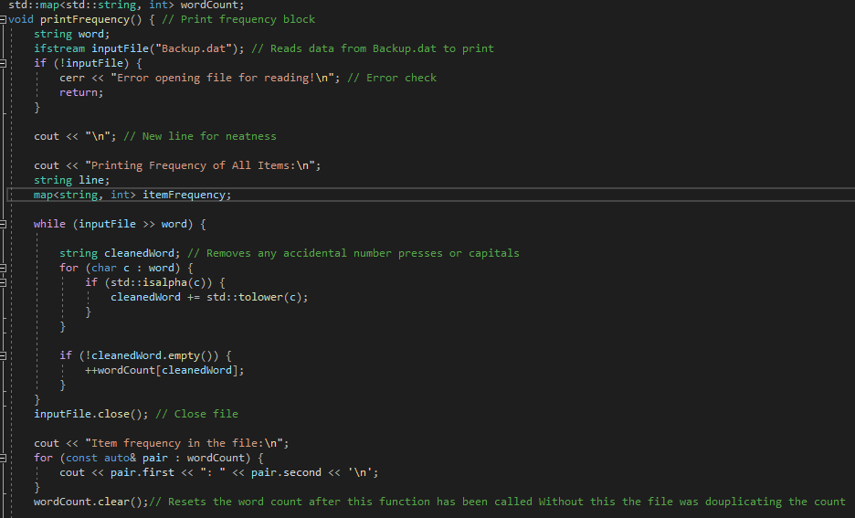

This works by first cleaning the word, removing any accidental key presses(this part is a bit redundant as you would get a syntax error in adding an item, but in case the Backup.dat was altered, it's here) as well as any capitals and turns this into the “Cleaned Word” this cleaned word is running through a word count to count the number of times this word appears in the text file. The histogram is practically the same code but with an adjustment at the bottom to print asterisks instead of a count. NOTE: These screenshots were taken when I was using

Backup.dat as a starting reference point; the way that I wrote this program was initially to work in backup.dat and then tackle writing to multiple files, a task that at the time I was expecting to be a lot more intimidating this has been changed to incode to reflect the correct textfile